Part A
Name:- Parva Gaglani
Roll No:- C172
Subject:- Data Structures and Algorithms
Program: B Tech Integrated CE 4th Year
Aim:
To study and implement concept of linear and circular queue data structure
Prerequisite: C++ Programming
Outcome: To implement circular queue and its operations.
- Theory:
Linear Queue

A queue is a FIFO (First-In, First-Out) data structure in which the element that is inserted first is the first one to be taken out.
The elements in a queue are added at one end called the REAR and removed from the other end called the FRONT.
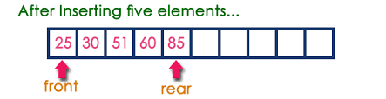
Queue ADT:
Queue Q, Front, Rear
Operations
1. Insert(Q, val) – Insert new element at the end of the queue.
2. Remove (Q)- Removes element from the front of the queue.
3. isEmpty(Q)- returns true if queue is empty else returns false
4. IsFull(Q)- returns true if queue is full else returns false
Insert operation
- Step 1: IF REAR == MAX-1
  - Write OVERFLOW
  - Goto step 4
  - [END OF IF]
- Step 2: IF FRONT = -1 and REAR = -1
  - SET FRONT = REAR = 0
  - ELSE
  - SET REAR = REAR + 1
  - [END OF IF]
- Step 3: SET QUEUE[REAR] = NUM
- Step 4: EXIT

Remove operation
- Step 1: IF FRONT == -1 OR FRONT > REAR
  - Write UNDERFLOW
- ELSE
  - SET VAL = QUEUE[FRONT]
  - SET FRONT = FRONT + 1
- [END OF IF]
Step 2: EXIT

Circular Queue

In linear queue, even though there is space available, the overflow condition still exists because the condition rear = MAX – 1 still holds true.
This is a major drawback of a linear queue.
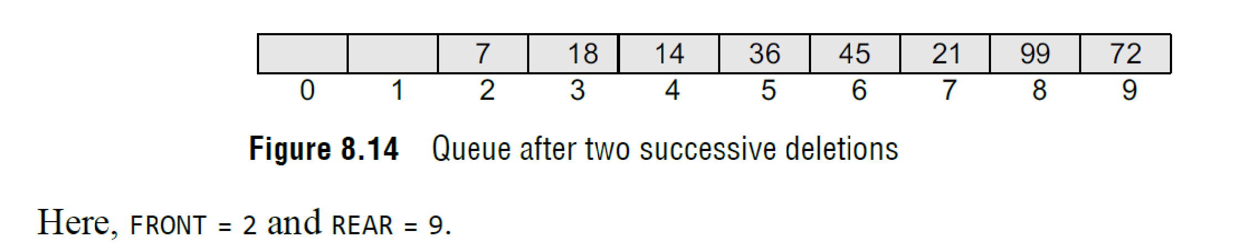Circular queue overcomes the disadvantage of linear queue. In the circular queue, the first index comes right after the last index. Conceptually, you can think of a circular queue as shown in Fig. 8.15
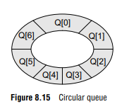

Queue ADT:
Queue Q, Front, Rear
Operations
1. Insert(Q, val) – Insert new element at the end of the queue.
2. Remove (Q)- Removes element from the front of the queue.
3. isEmpty(Q)- returns true if queue is empty else returns false
4. IsFull(Q)- returns true if queue is full else returns false

Insert operation
- Step 1: IF ((FRONT = 0 and Rear = MAX – 1 ) || (Front==Rear +1 ))
  - Write OVERFLOW, Goto step 4
  - [END OF IF]
- Step 2: IF FRONT = -1 and REAR = -1
  - SET FRONT = REAR = 0
  - ELSE IF REAR = MAX - 1 and FRONT != 0
  - SET REAR = 0
  - ELSE
  - SET REAR = REAR + 1
  - [END OF IF]
- Step 3: SET QUEUE[REAR] = VAL
- Step 4: EXIT

Remove operation
- Step 1: IF FRONT = -1
  - Write UNDERFLOW
  - Goto Step 4
  - [END of IF]
- Step 2: SET VAL = QUEUE[FRONT]
- Step 3: IF FRONT == REAR
  - SET FRONT = REAR = -1
  - ELSE
  - IF FRONT = MAX -1
  - SET FRONT = 0
  - ELSE
  - SET FRONT = FRONT + 1
  - [END of IF]
  - [END OF IF]
Step 4: EXIT
Procedure:
- Implement linear and circular queue
- Open CodeBlock editor or visual studio editor and write the code in C++.
- Complile and run the code
Instructions:

- Copy code & paste in code section and output of Part B.

Part B
Code:
Linear Queue:
#include<iostream>
using namespace std;
int rear=-1, front=-1;
const int MAX = 5;
int queue[100];

void Qinsert(int item, int queue[]) {
if (rear == MAX-1){
cout<<"queue overflow";
return;
} else {
if (front==-1)
{
front=0;
}

rear = rear + 1;
queue[rear] = item;

}
}

void Qremove() {
if (front == -1){
cout<<"queue underflow";
return;
} else {
int item = queue[front];
front = front+1;
cout<<item<<" is removed";
if (front>rear)
{
front = rear= -1;
}

}
}

void display() {
if (front == -1){
cout<<"queue underflow";
return;
} else {
for (int i = front; i <= rear; i++){
cout<<queue[i]<<" ";
}
}
}

int main() {
int ch;
do
{
cout<<endl;
cout<<"1:insert 2:remove 3:display 4:Exit"<<endl;
cout<<"Enter choice: ";
cin>>ch;
switch (ch)
{
case 1:
int val;
cout<<"Enter value: ";
cin>>val;
Qinsert(val, queue);
break;

case 2:
Qremove();
break;

case 3:
display();
break;

case 4:
cout<<"Exiting!!";
return 0;

default: {
break;
}
}
} while (ch!=4);

}

Circular Queue:
#include <iostream>
using namespace std;

const int MAX=5;
int queue[MAX], front=-1,rear=-1;

void insert(int val)
{
if((rear+1)% MAX==front)
{
cout<<"Overflow"<<endl;
}
else
{
if(front==-1)
front=rear=0;
else
rear=(rear+1)% MAX;
queue[rear]=val;
cout<<"Inserted "<<val<<endl;
}
}

void Delete()
{
if(front==-1)
{
cout<<"Underflow"<<endl;
}
else
{
cout<<"Deleted "<<queue[front]<<endl;
if(front==rear)
{
front=rear=-1;
}
else
front=(front+1)%MAX;
}
}

int main()
{
int val,choice;
while (true)
{
cout << "\nQueue Operations:\n1. Insert\n2. Delete\n3. Exit\n";
cout << "Enter your choice: ";
cin >> choice;

switch (choice)
{
case 1:
cout << "Enter value to insert: ";
cin >> val;
insert(val);
break;
case 2:
Delete();
break;
case 3:
cout << "Exiting..." << endl;
return 0;
default:
cout << "Invalid choice! Please try again." << endl;
}
}
return 0;
}

Output:

Linear Queue:
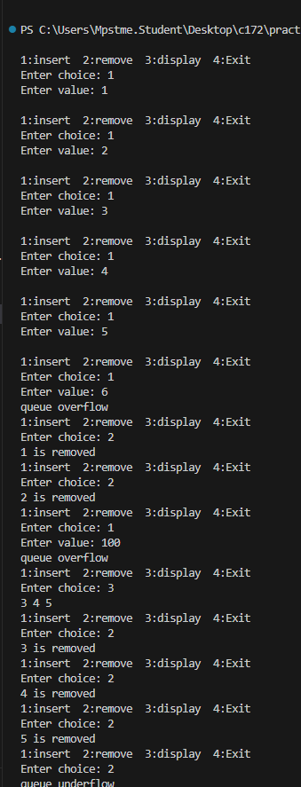
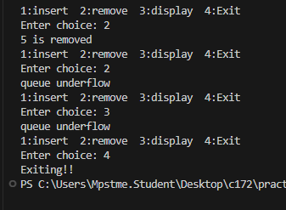

Circular Queue:

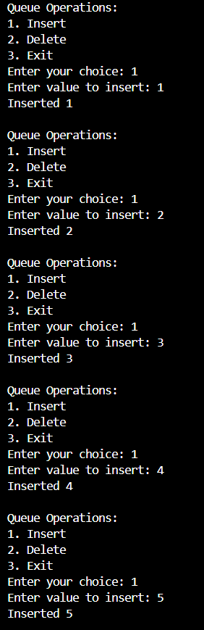
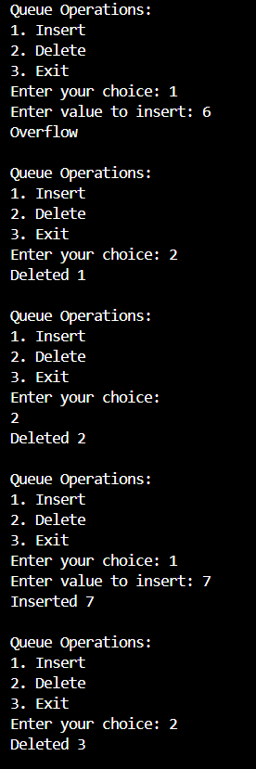
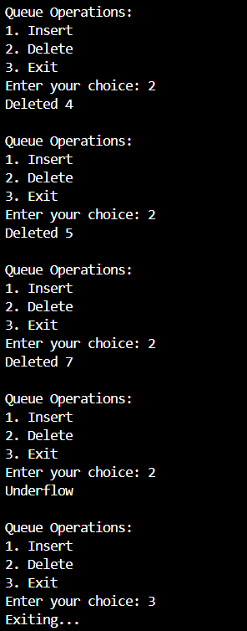

Observation & Learning:
Write your Observations & Learning after performing task
Answer Following Question
- A linear queue, if implemented using an array of size MAX_SIZE, gets full when?
a) Rear == MAX_SIZE – 1
b) Front == (rear + 1)mod MAX_SIZE
c) Front == rear + 1
d) Rear == front
Answer: a)
- A linear queue, if implemented using an array of size MAX_SIZE, gets empty when?
a) Front== MAX_SIZE – 1
b) Rear == -1 Or FRONT > REAR
c) Front == rear + 1
d) Rear == front
Answer:b)

- A circular queue, if implemented using an array of size MAX_SIZE, gets full when?
a) Rear == MAX_SIZE – 1
b) Front == (rear + 1)mod MAX_SIZE
c) FRONT = 0 and Rear = MAX – 1 ) || (Front==Rear +1 )
d) Rear == front
Answer: b)
- A circular queue, if implemented using an array of size MAX_SIZE, gets empty when?
a) Front== MAX_SIZE – 1
b) Rear == -1
c) Front == rear + 1
d) Rear == front
Answer:c)
- Write any two applications of queue data structure.
Ans-
Job Scheduling in Operating Systems – Queues manage tasks like CPU scheduling, where processes are handled in the order they arrive (FIFO).
Print Queue – Documents sent to a printer are queued and printed in the order they were submitted.

Conclusion:
We successfully implemented linear queue and its operations using C++ program. .

